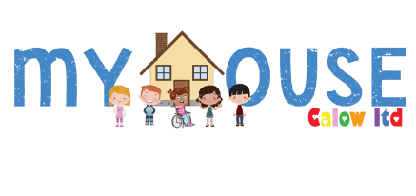
Skills: | Essential | Desirable
Requirement:

The ability to communicate with children and young people | 
The ability to manage and respond appropriately to challenging behaviour

To be a good team member

To work on your own initiative

To work unsupervised

Skills in leisure activities relevant to young people

Excellent communication skills

Ability to work under pressure or in difficult situations

Excellent organisational skills

Time Management skills

Knowledge: | Essential | Desirable
Requirement:

Appreciation of the needs of young people

understanding of good quality residential care

An understanding of appropriate legislation, e.g. Children Act, Criminal Justice Act, Children’s Homes Regulations, including the quality standards, England (2015)

Understanding of the complexities of disabled children. Particularly in relation to promoting their privacy dignity, when providing personal care.

Knowledge of person-centred plans/Reviews

Good working knowledge of positive behavioural support and its principles

Knowledge of assessment, audit, monitoring and review

Experience: | Essential | Desirable
Requirement:

Experience of supporting children with disabilities, Mental Health issues, High Functioning Autism

Experience of working with children in need and their families

Experience of working with children in need (Section 17), young people who are or who have been voluntarily accommodated (Section 20) and looked after children (Section 31)

Group work/Teamwork skills

Experience of working in a service
regulated by Ofsted

Experience of supporting children with behaviours that challenge/find it difficult to manage their emotions

Experiences with children or adults who have experienced trauma, separation from family and friends

Experience of working with disabled children and young people including moving and handling and supporting with personal care.

Experience of holding supervision and leading a shift
Experience in a supervisor role

Qualifications: | Essential | Desirable
Requirement:

Level 3 Diploma Children and Young People or an equivalent qualification.
Personal commitment to anti-oppressive care practices

Supervision Training /Leadership and management training

Ability to work flexibly according to needs of the service

Ability to travel, as required, between departmental service outlets throughout the county

Personal commitment to own learning and the acquisition of professional skills

Ability to benefit from supervisory and monitoring relationships

Minimum age 21 years old
Clean driving licence
(A casual car user allowance is attached to this post, but it is possible for the allowance to be converted to other forms of transport where there is a requirement to undertake travel as part of this post.)

Personal Attributes | Essential | Desirable
Requirement:

Trustworthy

Honest

Reliable

Kind/Caring

Fun

Positive attitude

Professional

Passionate about making a difference

Calm

Warm/Friendly personality

Flexible

Confident

